***SHUBHAM GARG***

***BATCH F2***

***9919103057***

**QUESTION 1**

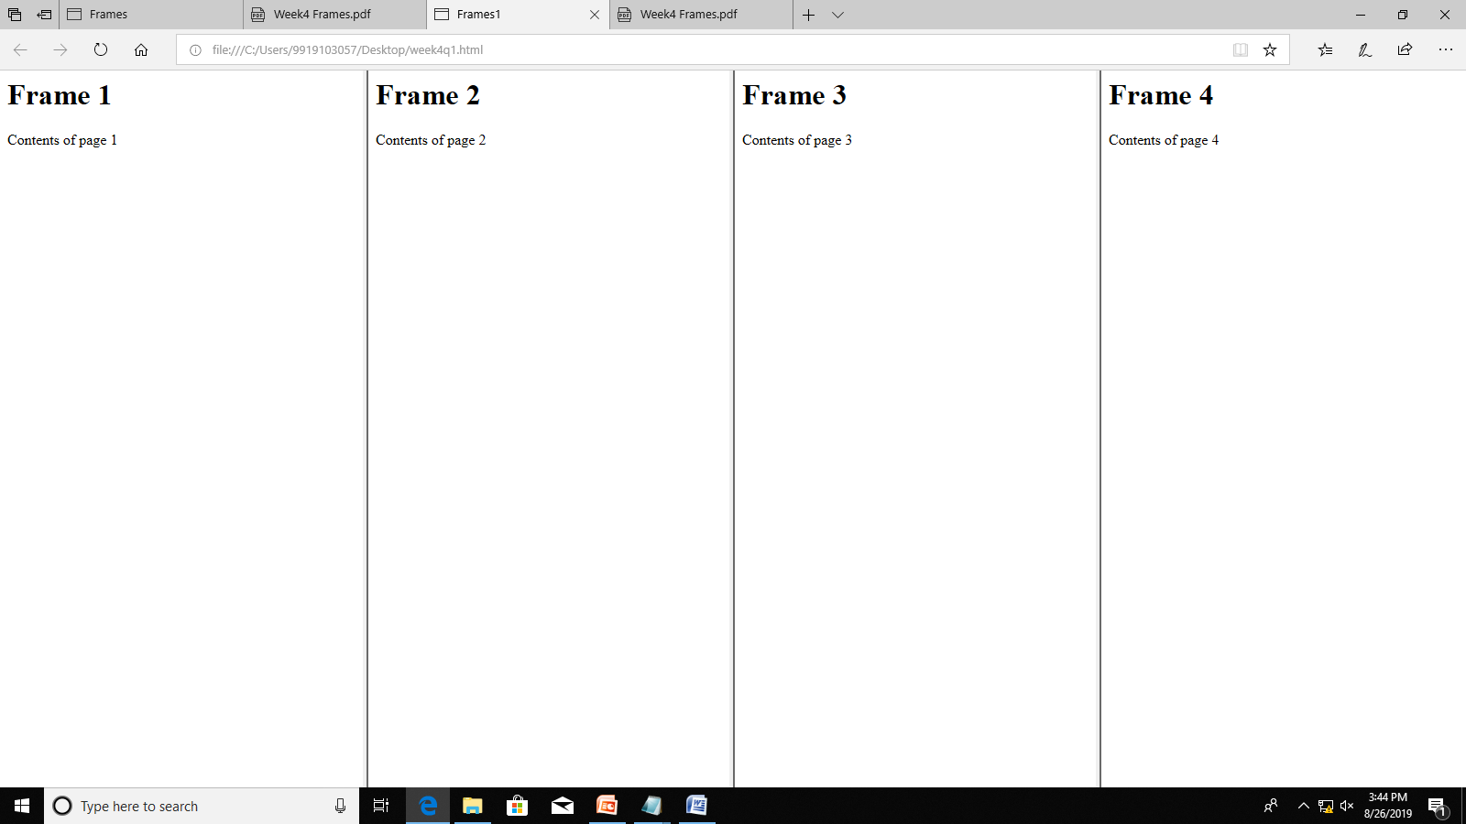

<html>

<head>

<title>Frames1

</title>

</head>

<frameset cols="25%,25%,25%,25%">

<frame src="frame11.html">

<frame src="frame12.html">

<frame src="frame13.html">

<frame src="frame14.html">

</frameset>

</html>

<html>

<head>

<title>Frames1

</title>

</head>

<frameset cols="25%,25%,25%,25%">

<frame src="frame11.html">

<frame src="frame12.html">

<frame src="frame13.html">

<frame src="frame14.html">

</frameset>

</html>

<html>

<head>

<title>Frame12

</title>

</head>

<body>

<h1>Frame 2<br></h1>

Contents of page 2

</body>

</html>

<html>

<head>

<title>Frame13

</title>

</head>

<body>

<h1>Frame 3<br></h1>

Contents of page 3

</body>

</html>

<html>

<head>

<title>Frame14

</title>

</head>

<body>

<h1>Frame 4<br></h1>

Contents of page 4

</body>

</html>

**QUESTION 2**

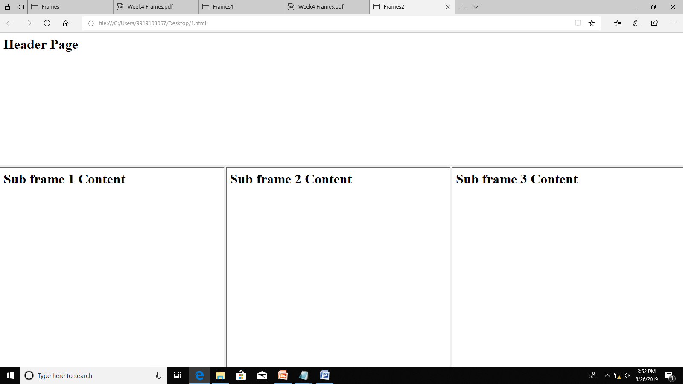

<html>

<head>

<title>Frames2

</title>

</head>

<frameset rows="40%,60%">

<frame src="frame14.html">

<frameset cols="33%,33%,34%">

<frame src="frame11.html">

<frame src="frame12.html">

<frame src="frame13.html">

</frameset>

</frameset>

</html>

<html>

<head>

<title>Frame14

</title>

</head>

<body align="center">

<h1>Header Page</h1>

</body>

</html>

<html>

<head>

<title>Frame11

</title>

</head>

<body>

<h1> Sub frame 1 Content</h1>

</body>

</html>

<html>

<head>

<title>Frame12

</title>

</head>

<body>

<h1> Sub frame 2 Content</h1>

</body>

</html>

<html>

<head>

<title>Frame13

</title>

</head>

<body>

<h1> Sub frame 3 Content</h1>

</body>

</html>

**Question 3**

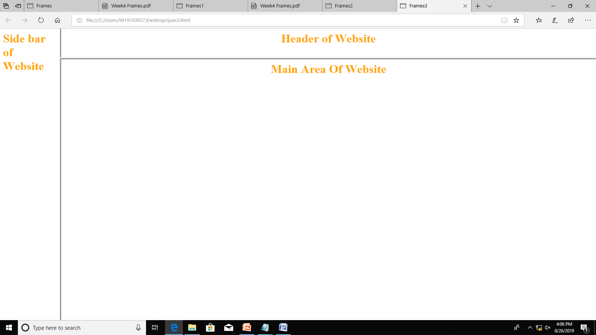

<html>

<head>

<title>Frames3

</title>

</head>

<frameset cols="10%,90%">

<frame src="frame14.html">

<frameset rows="10%,90%">

<frame src="frame11.html">

<frame src="frame12.html">

</frameset>

</frameset>

</html>

<html>

<head>

<title>Frame14

</title>

</head>

<body>

<font color="orange"><h1>Side bar of Website</h1></font>

</body>

</html>

<html>

<head>

<title>Frame11

</title>

</head>

<body>

<h1><center><font color="orange">Header of Website</font></center></h1>

</body>

</html>

<html>

<head>

<title>Frame12

</title>

</head>

<body>

<h1><center><font color="orange">Main Area Of Website</font></center></h1>

</body>

</html>

**QUESTION 4**

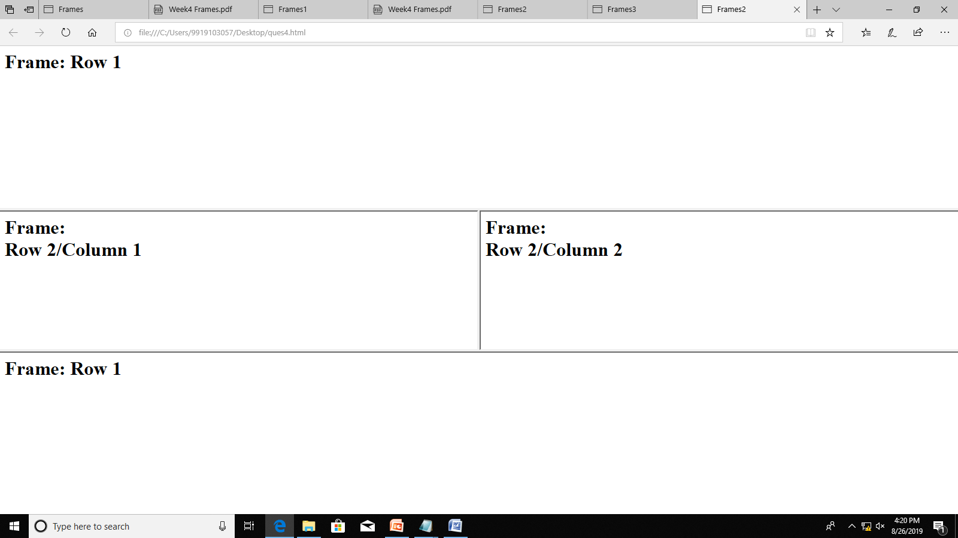

<html>

<head>

<title>Frames2

</title>

</head>

<frameset rows="35%,30%,35%">

<frame src="frame14.html">

<frameset cols="50%,50%">

<frame src="frame11.html">

<frame src="frame12.html">

</frameset>

<frame src="frame14.html">

</frameset>

</html>

<html>

<head>

<title>Frame11

</title>

</head>

<body>

<h1>Frame:<br>

Row 2/Column 1</h1>

</body>

</html>

<html>

<head>

<title>Frame12

</title>

</head>

<body>

<h1>Frame:<br>

Row 2/Column 2</h1>

</body>

</html>

<html>

<head>

<title>Frame13

</title>

</head>

<body>

<h1> Frame: Row 3</h1>

</body>

</html>

**QUESTION 5**

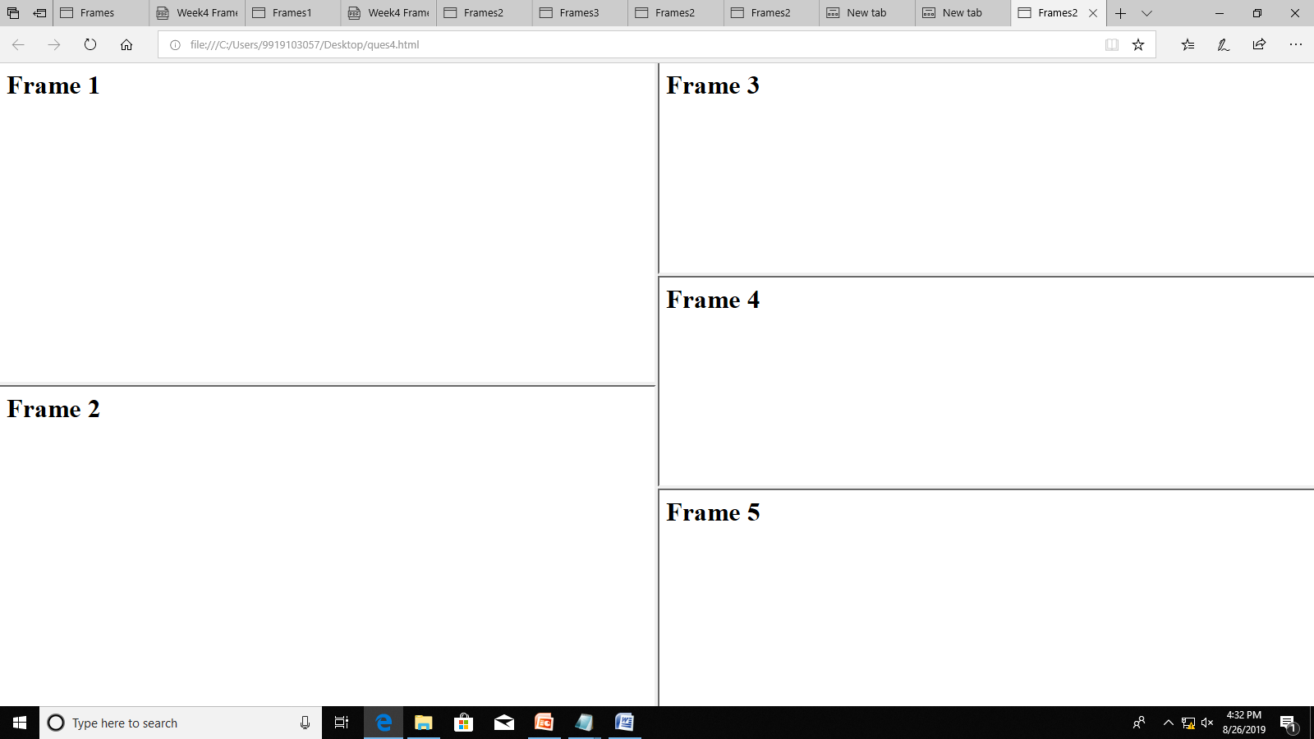

<html>

<head>

<title>Frames2

</title>

</head>

<frameset cols="50%,50%">

<frameset rows="50%,50%">

<frame src="frame11.html">

<frame src="frame12.html">

</frameset>

<frameset rows="33%,33%,34%">

<frame src="frame13.html">

<frame src="frame14.html">

<frame src="1.html">

</frameset>

</frameset>

</html>

<html>

<head>

<title>Frame11

</title>

</head>

<body>

<h1>Frame 1</h1>

</body>

</html>

<html>

<head>

<title>Frame12

</title>

</head>

<body>

<h1>Frame 2</h1>

</body>

</html>

<html>

<head>

<title>Frame13

</title>

</head>

<body>

<h1> Frame 3</h1>

</body>

</html>

<html>

<head>

<title>Frame14

</title>

</head>

<body>

<h1> Frame 4</h1>

</body>

</html>

<html>

<head>

<title>Frames2

</title>

</head>

<body>

<h1> Frame 5</h1>

</body>

</html>

**QUESTION 6**

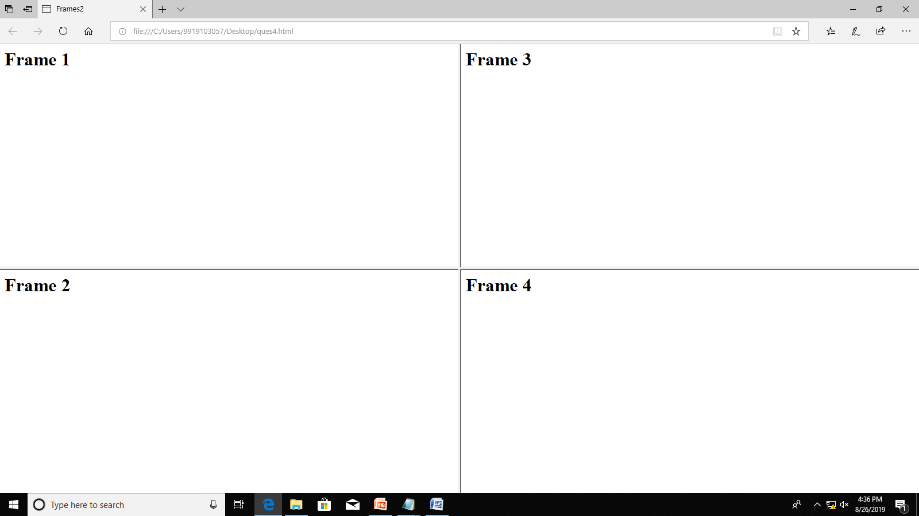

<html>

<head>

<title>Frames2

</title>

</head>

<frameset cols="50%,50%">

<frameset rows="50%,50%">

<frame src="frame11.html">

<frame src="frame12.html">

</frameset>

<frameset rows="50%,50%">

<frame src="frame13.html">

<frame src="frame14.html">

</frameset>

</frameset>

</html>

<html>

<head>

<title>Frame11

</title>

</head>

<body>

<h1>Frame 1</h1>

</body>

</html>

<html>

<head>

<title>Frame12

</title>

</head>

<body>

<h1>Frame 2</h1>

</body>

</html>

<html>

<head>

<title>Frame13

</title>

</head>

<body>

<h1> Frame 3</h1>

</body>

</html>

<html>

<head>

<title>Frame14

</title>

</head>

<body>

<h1> Frame 4</h1>

</body>

</html>